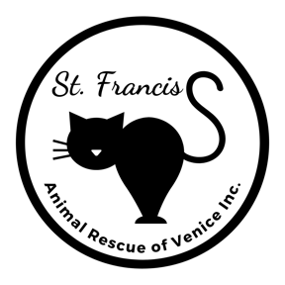
Sponsor Application
1925 S. Tamiami Trail, Venice FL 34293 941.492.6200

Do you love cats but are unable to have the pleasure of providing a home for one? Why not consider sponsoring one of our resident cats?

These special kitties will never be adopted into a home because of behavioral, physical or medical challenges, but they would love to have someone to call their own.

For a $100 donation, one of our resident cats can be “yours” for a year. You will receive a photo of your kitty and three personalized letters letting you know what’s happening in his or her life at the shelter. You may also make an appointment to visit your sponsored cat by calling or emailing in advance to confirm a volunteer is available to assist you during your visit.

Your contribution helps provide food, shelter and medical care that your cat needs throughout the year.

TELL US ABOUT YOURSELF

Name: | Email:
Street Address: | Phone-Cell:
City/State/Zip: | Phone-Other:

TELL US WHICH RESIDENT CAT(S) YOU ARE INTERESTED IN SPONSORING
($100 per year/per cat)

1. | 5. | 9.
2. | 6. | 10.
3. | 7. | 11.
4. | 8. | 12.

Signature of Applicant: ______________________________________________ Date: ____________________________

Payment can be made by check payable to St. Francis Animal Rescue, note “Sponsor” in memo field.
Mail to or drop off with completed form at 1925 S. Tamiami Trail, Venice FL 34293
Credit cards accepted onsite.

[rev 07.20.23 SB]

