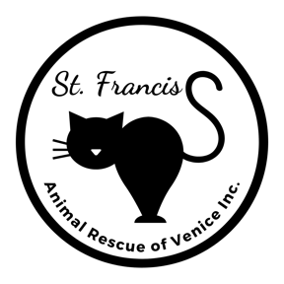
Relinquishment Request
1925 S. Tamiami Trail, Venice FL 34293 941.492.6200

RELINQUISHER INFORMATION
Date: | Name:
Phone #: | City:

Timeframe to Relinquish: | Person filling out form:

CAT INFORMATION
STRAY CAT

How/where did you find this cat? | When did you find this cat?

(If you have had the cat for less than 3 days, please call Sarasota County Animal Services (941) 861-9500. A “Stray Hold” must be done on any stray animal found in the county. If you are concerned that the county will euthanize the cat, please know that rescues work closely with Animal Services to get all cats adopted and we often take cats from them.)

PERSONAL PET

Name of Cat: | How long have you had the cat? |  |  | DOB or age (if known):
Breed: DSH DMH DLH  Other: |  |  | Color: | Weight (if known):
Sex: Male Female | Spayed/Neutered: No Yes |  |  | Declawed: No Yes
Microchipped? No Yes | If yes, microchip company:
Indoor Outdoor In & Out |  | Where did you acquire this pet? SFAR  Other:

If a SFAR cat, please fill out the following information so we can locate the original file
Person who adopted the cat: | When cat was adopted: | SFAR cat name:

(We will take back a verified adopted SFAR cat regardless of age/health BUT we need to schedule the time the cat can come in. This is done AFTER we counsel you and try to keep the cat in the home.)

RELINQUISHMENT DETAILS
Reason for relinquishment:
If we could offer you assistance to keep your cat, would you be interested? No Yes
If yes, what assistance would you need?
Food Litter Help with medical care Behavior modification
Other:

MEDICAL CARE
Did you take the cat to a veterinarian? No Yes | Date:
Name of Veterinarian: | Phone #:
Veterinary services performed on this cat:
Up to date on vaccines (Rabies/FVRCP): No Yes | Date:
Flea prevention medicine: No Yes  If yes, type: | Date:
Known medical condition: No Yes
If yes, describe:
Medications: No Yes
If yes, type:
Tested for FELV/FIV: No Yes
If yes, results: Negative for both FELV+ FIV+

BEHAVIORS
Check all that apply: Shy Outgoing Lap cat Friendly Sweet
Hissy Nippy History of bites Aggressive
Litter box issues: No Yes
If yes: Pees outside box Poops outside box Pees & poops outside box
Gets along with: Other cats Small dogs Large dogs Children
Other:

BEFORE YOU RELINQUISH
Please consider rehoming. It is less stressful for a cat to be rehomed directly rather than go to a shelter.
Rehoming Resources
- Nextdoor.com
- AdoptAPet.com
- Home-Home.org
- Facebook
- Other area shelters/rescues
(rev 10.12.23)

