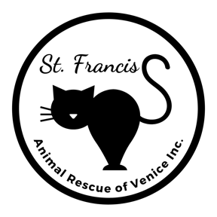
Adoption Application
1925 S. Tamiami Trail, Venice FL 34293 941.492.6200

I am interested in adopting: ________________________

TELL US ABOUT YOURSELF
Name: | Spouse/Partner:
Street Address: | Phone-Cell:
City/State/Zip: | Phone-Home:
Email: | Phone-Work:

TELL US ABOUT YOUR CURRENT PETS
# of Dogs: Spayed/Neutered? Yes No |  | # of Cats: Spayed/Neutered? Yes No
Other:
Veterinarian: | Clinic: |  | Phone:
What are your plans for your pets if you are no longer able to care for them?

TELL US ABOUT WHERE THE ADOPTED CAT WILL LIVE
Do you Own or Rent your home? Own Rent If Rent, please provide copy of your lease.
# of Adults: | # of Children: | Ages of Children:
Does anyone have allergies to cats? Yes No If Yes, how severe?
Where will you keep your adopted cat? Indoor Screened Lanai Outdoor Indoor/Outdoor
Will you allow a St. Francis representative to visit your home to see where the cat is living? Yes No
If No, please explain:
Do you plan on having your cat declawed? Yes No
What will you do if your cat scratches or shows other destructive behavior?

By signing this application, I agree and understand that:
- I must be 21 years of age or older and provide photo ID.
- I must provide proof of home ownership (property tax record) or lease showing pets allowed.
- Pets are a 20-year commitment; I am able to commit to the long-term care for this animal.
- Estimated annual cost of owning a cat is $750 (not including medical emergencies); I am able to afford the cost.
- DECLAWING IS NOT ALLOWED FOR ANY ANIMAL ADOPTED FROM ST. FRANCIS.
- St. Francis Animal Rescue can deny the adoption for any reason.

Signature of Applicant: ______________________________________________ Date: ____________________________

I hereby grant permission to St. Francis Animal Rescue to use any photos/videos of me and my cat(s) for publication in print and online for purposes of promoting the mission of St. Francis Animal Rescue of Venice Inc. Yes No

Submit completed form to: St. Francis Animal Rescue, 1925 S. Tamiami Trail, Venice FL 34293 - or - Email sfarvenice@gmail.com
For Office Use
Adoption Counselor: _________________________________________
Residence Verified: Property Tax Lease Other __________________________________________________________
Adoption Approved: Yes No If No, please explain: __________________________________________________________
Adoption Completed By: ______________________________________ Scanned Checked DNA List [rev03.03.22]

